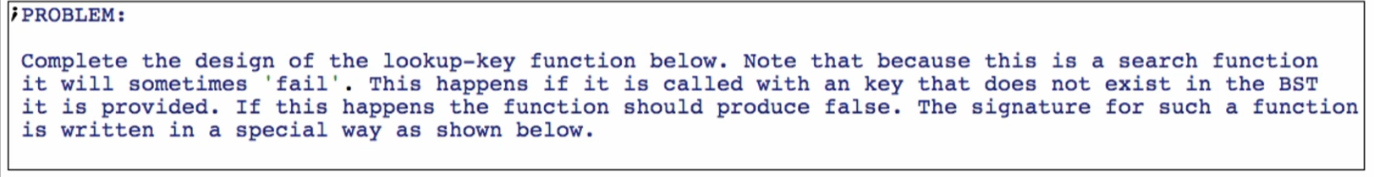

***Function definition***

**Signature, purpose, and stub**



**Examples**

Base case:



Other cases:

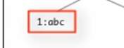

Success in BST size 1 – node itself



Fail in right branch of BST size 1



Fail in the left branch of BST size 1



Note:

* We have 2 self-reference cases, and need tests to check whether they are both working properly hence the failing and succeeding in the left branch (first SR) and failing in the right branch (second SR) and they must be AT LEAST TWO BRANCHES DEEP

Successes in the left branch

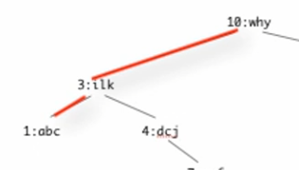



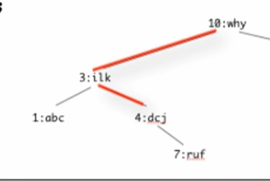



Successes in the right branch

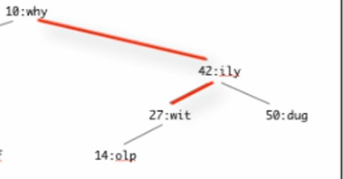

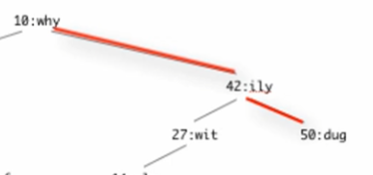

Full examples:

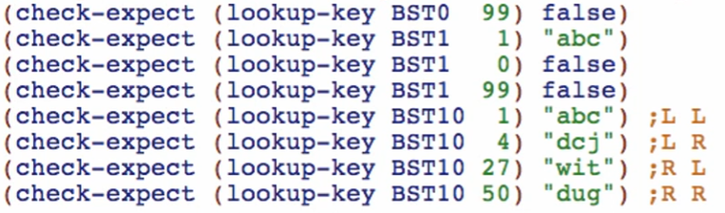

**Template**

Rename function and natural recursions and add the extra atomic parameter after each …

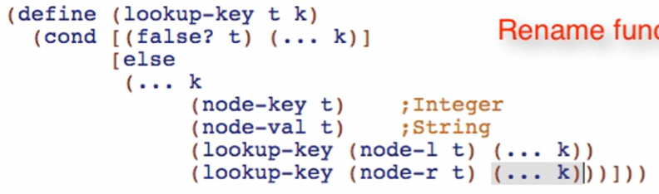

**Code body**

Base case

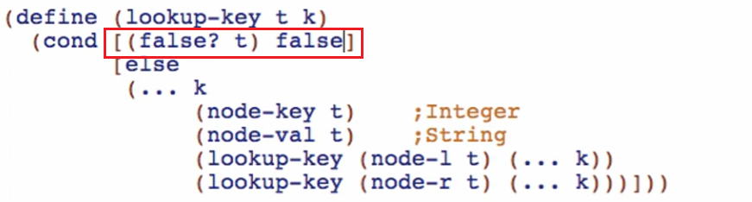

Other cases

Right at the thing you were looking for:



Going through the tree and failed



Going through the tree and succeed

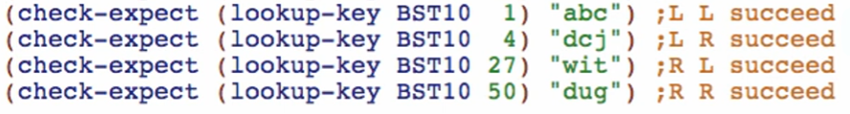

This is a total of 3 cases!

Cut this first and make it as question and answer for cond for 3 cases

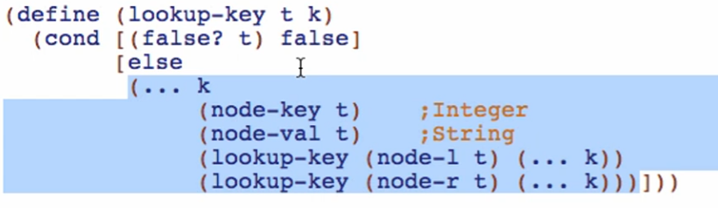

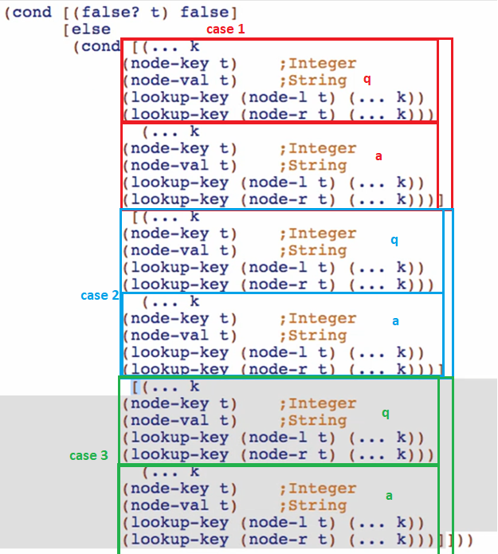

**Code body**

1st condition: Right at the thing you were looking for:

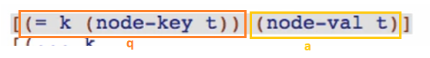

2nd condition: Going left

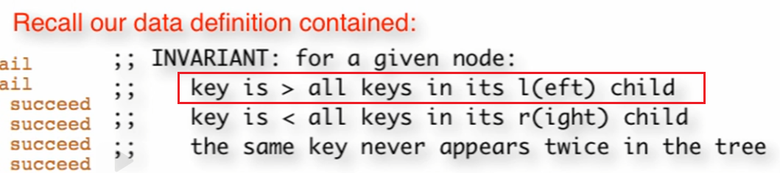

Q: 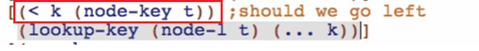

A:

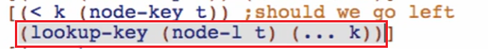



3RD condition: Going Right

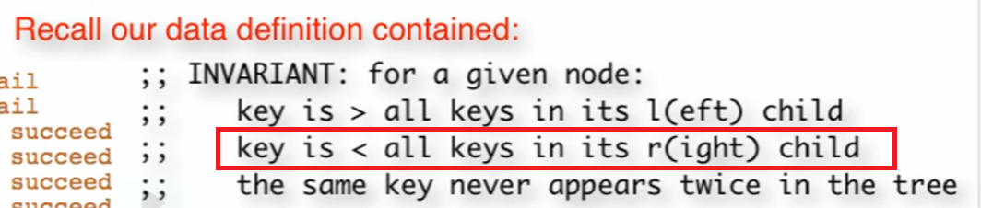

Q: 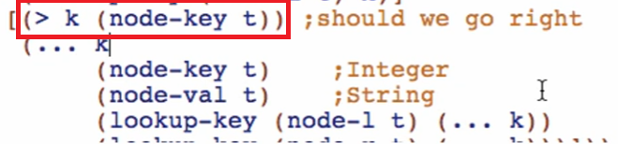

A:

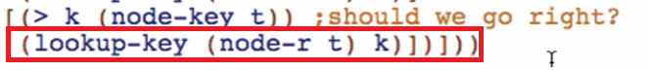

Final code body:

